Iteration 1

# Summary

TBD

# Process for Iteration 1

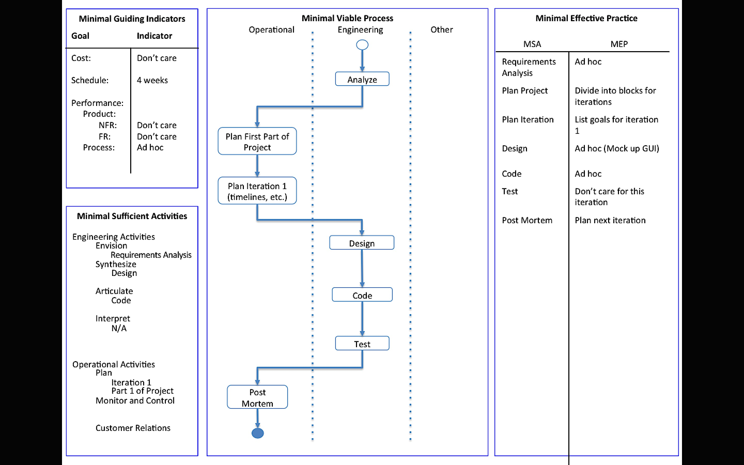

# Goals for Iteration 1

* Clean up the code developed over 2015 and keep only the material relevant to this project.
* Add a graphic user interface to increase the quality of the project.
* Analyze the results of current black and white extended visual cryptography scheme to look for ways of improvement or prepare for it to evolve into handling gray scale images.

# Source Code

TBD